

HITEC University, Taxila
BS Cyber Security 3rd Semester
Fall 2025

Lab Report # 12

Subject: Artificial intelligence

Submitted By: Abdul Majid (24-CYS-021)
Muhammad Usama (24-CYS-013)

Section: B

Submitted To: Mr Mubashir Iqbal

BS Cyber Security Program Department of Computer Science HITEC UNIVERSITY, TAXILA

Task no 01:
Take any real-world example and apply a Random Forest classifier to it.

Results:
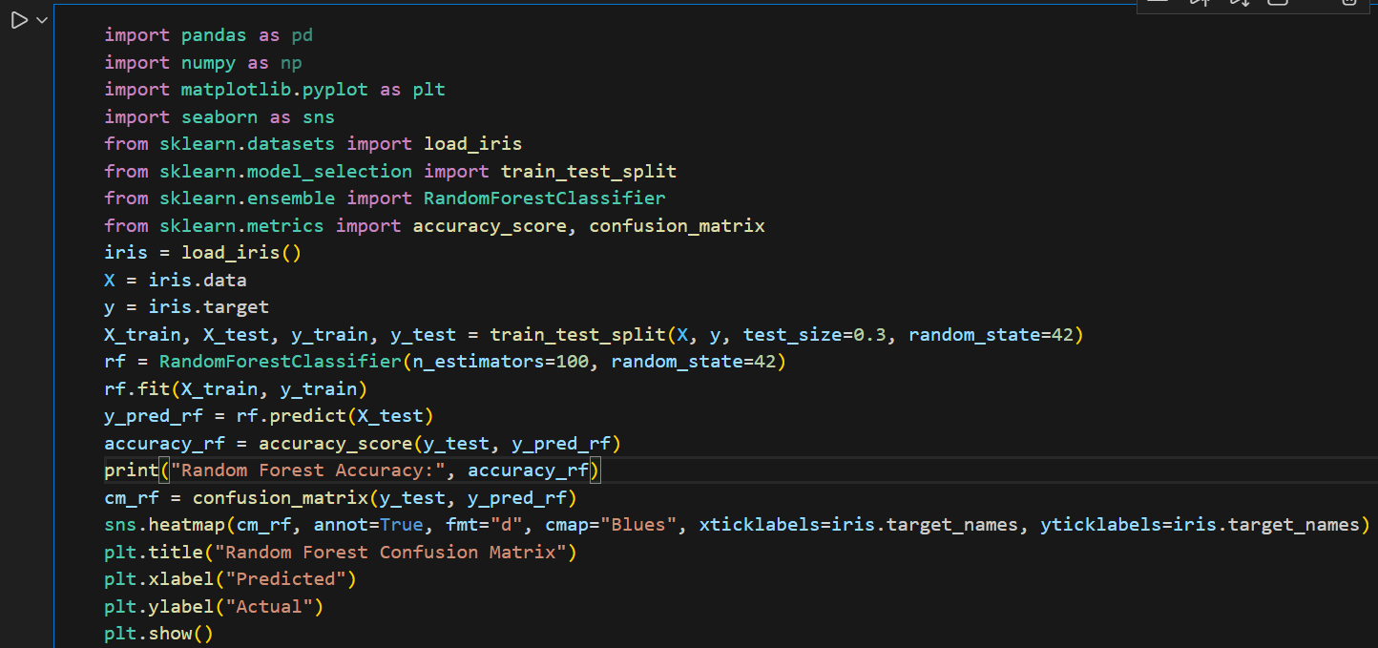
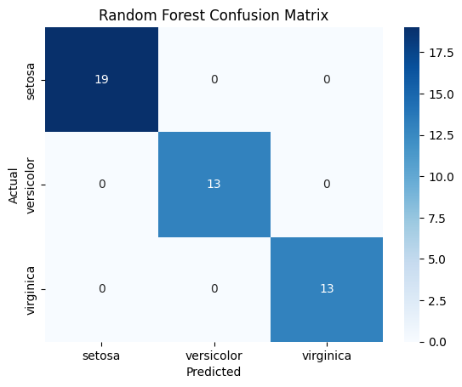

Explanation:
In this task, the Random Forest Classifier was applied to the Iris dataset, which contains features like sepal length, sepal width, petal length, and petal width to predict the species of the flowers. The dataset was first split into training and testing sets with a 70:30 ratio to evaluate model performance on unseen data. A Random Forest model with 100 decision trees was trained on the training set, and predictions were made on the test set. The model’s performance was evaluated using accuracy and a confusion matrix, which visually represented correct and incorrect classifications for each species. Random Forest combines multiple decision trees, which reduces overfitting and improves classification accuracy, making it highly effective for datasets with multiple features.

Task no 02:
Take any real-world example and apply the Decision Tree algorithm to it.

Results:
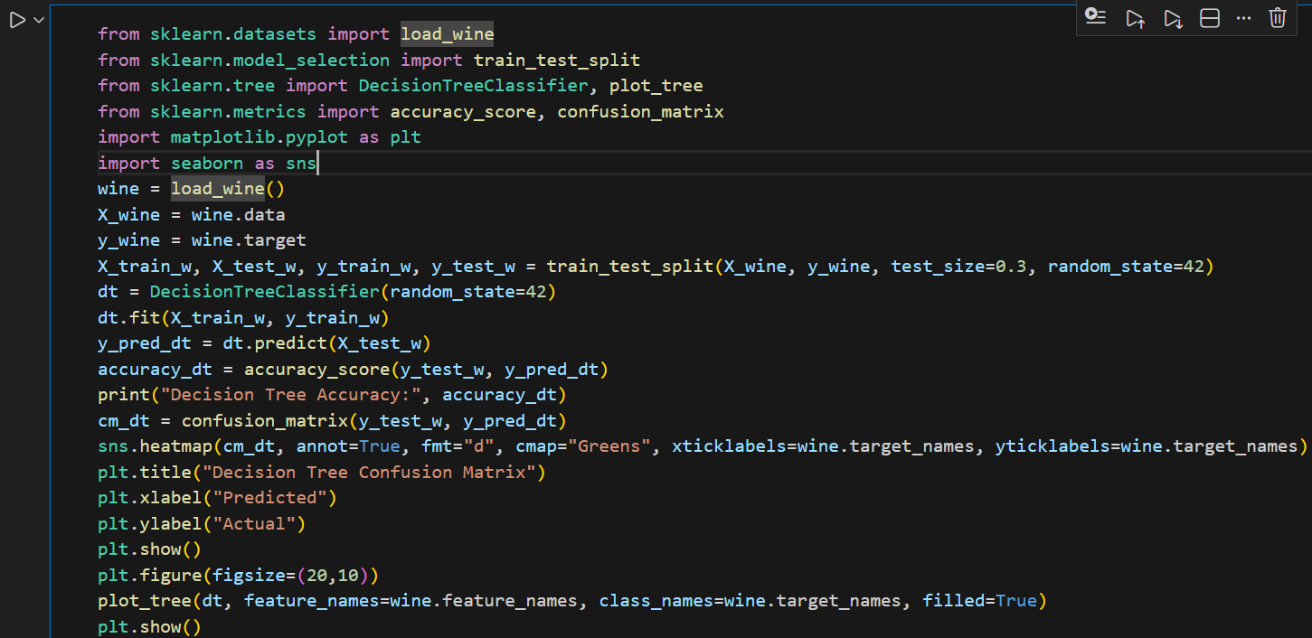
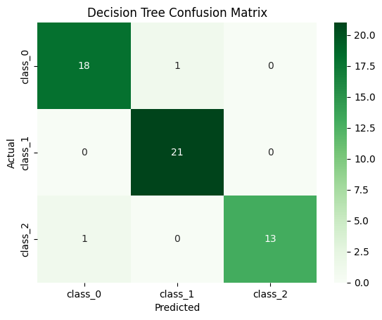
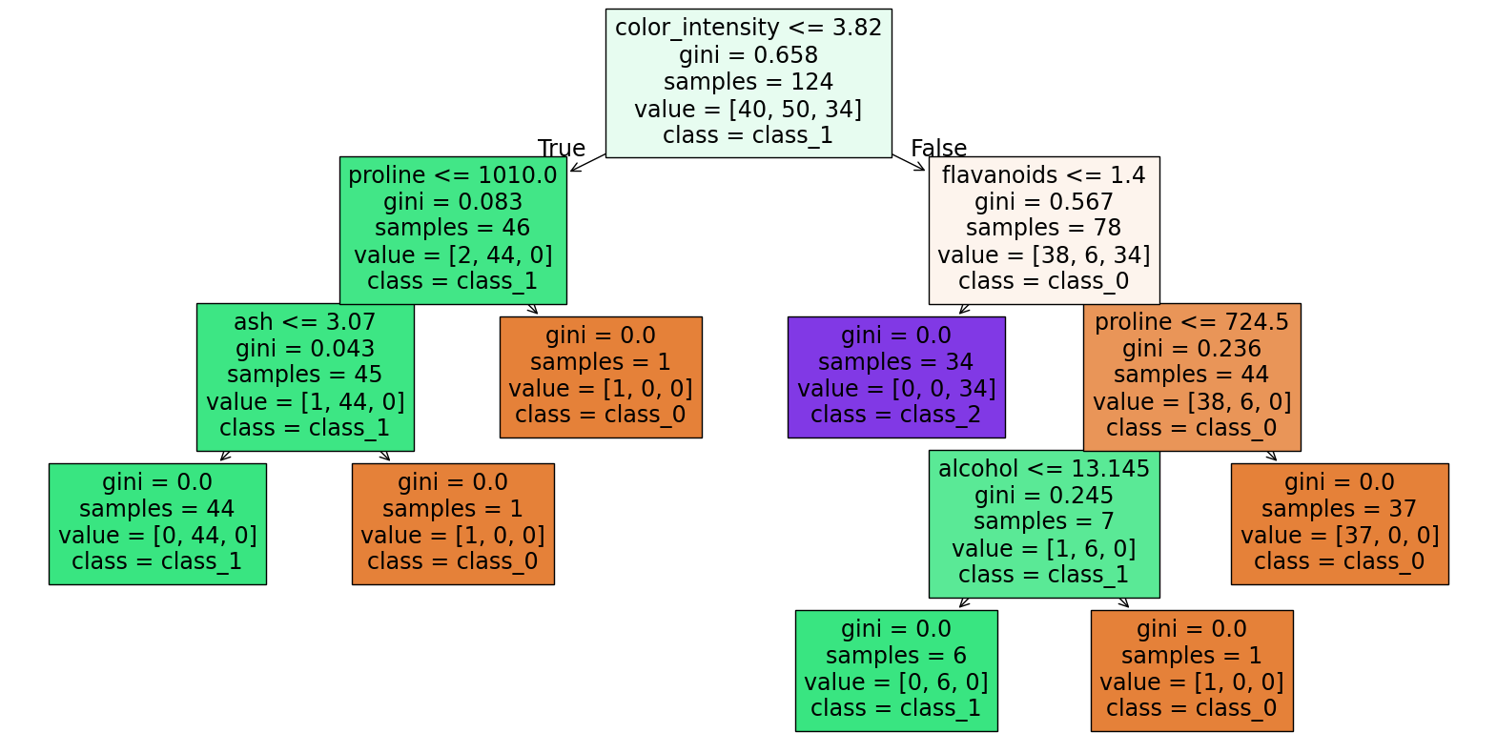

Explanation:
In this task, the Decision Tree Classifier was applied to the Wine dataset, which contains chemical features of wines to classify them into three categories. The dataset was first split into training and testing sets with a 70:30 ratio to evaluate the model on unseen data. A single decision tree was trained on the training set, and predictions were made on the test set. Model performance was assessed using accuracy and a confusion matrix, which visually shows correct and incorrect classifications for each wine class. Additionally, the decision tree was visualized to illustrate the decision rules and how feature thresholds determine class membership. Decision Trees are easy to interpret and visualize, making them useful for understanding decision-making logic, though they can overfit small datasets. This task demonstrates how a single decision tree can classify real-world data effectively while providing transparent decision paths.

Conclusion:
In this lab, two classification algorithms, Random Forest and Decision Tree, were applied to real-world datasets to demonstrate their effectiveness in supervised learning tasks. The Random Forest Classifier, applied to the Iris dataset, showed high accuracy by combining multiple decision trees, reducing overfitting, and providing robust predictions. The Decision Tree Classifier, applied to the Wine dataset, offered a simple and interpretable model, clearly showing how feature thresholds lead to class decisions. Both algorithms successfully classified the data, but Random Forest generally achieved higher accuracy due to ensemble learning, while Decision Trees provided transparency and ease of visualization. This lab highlights the trade-off between accuracy and interpretability, emphasizing that both methods are valuable tools in machine learning for different scenarios.

